Types of Morphemes

🧩 What Are the Types of Morphemes?
# Source: Chatgpt (GPT-4-turbo) at [7/24/2025]
In linguistics, morphemes are the smallest units of meaning in a language.
There are several types of morphemes based on function and independence.

🔹 Main Types of Morphemes
# Source: Chatgpt (GPT-4-turbo) at [7/24/2025]
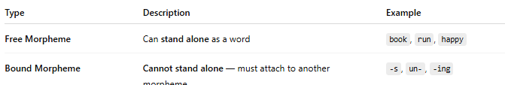
Type | Description | Example
Free Morpheme | Can stand alone as a word | book, run, happy
Bound Morpheme | Cannot stand alone — must attach to another morpheme | -s, un-, -ing

🔸 Types of Bound Morphemes
# Source: Chatgpt (GPT-4-turbo) at [7/24/2025]
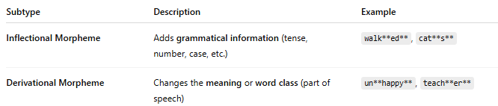
Subtype | Description | Example
Inflectional Morpheme | Adds grammatical information (tense, number, case, etc.) | walk**ed**, cat**s**
Derivational Morpheme | Changes the meaning or word class (part of speech) | un**happy**, teach**er**

🔹 Visual Summary:
# Source: Chatgpt (GPT-4-turbo) at [7/24/2025]
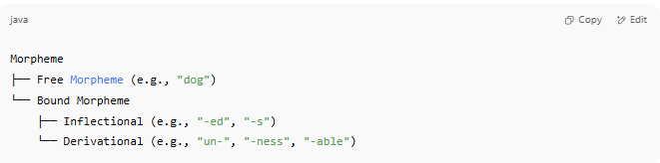
Morpheme
├── Free Morpheme (e.g., "dog")
└── Bound Morpheme
├── Inflectional (e.g., "-ed", "-s")
└── Derivational (e.g., "un-", "-ness", "-able")

✅ Example Breakdown:
# Source: Chatgpt (GPT-4-turbo) at [7/24/2025]
Word: "unbelievable"
- un- → bound derivational prefix
- believe → free morpheme
- -able → bound derivational suffix
🧠 Total morphemes: 3

✅ Summary:
# Source: Chatgpt (GPT-4-turbo) at [7/24/2025]
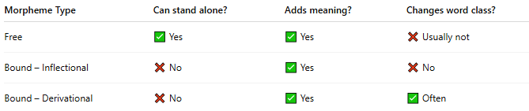
Morpheme Type | Can stand alone? | Adds meaning? | Changes word class?
Free | ✅ Yes | ✅ Yes | ❌ Usually not
Bound – Inflectional | ❌ No | ✅ Yes | ❌ No
Bound – Derivational | ❌ No | ✅ Yes | ✅ Often

